



Essay / Assignment Title: Applications of Data Analytics

Programme title: Fundamental of Data Analytics

Name: OPEYEMI SUNDAY ADETUNJI

Year: 2025

CONTENTS

Statement of compliance with academic ethics and the avoidance of plagiarism
I honestly declare that this dissertation is entirely my own work and none of its part has been copied from printed or electronic sources, translated from foreign sources and reproduced from essays of other researchers or students. Wherever I have been based on ideas or other people texts I clearly declare it through the good use of references following academic ethics.
(In the case that is proved that part of the essay does not constitute an original work, but a copy of an already published essay or from another source, the student will be expelled permanently from the program).

Name and Surname (Capital letters):
OPEYEMI SUNDAY ADETUNJI

Date: 13/06/2025

INTRODUCTION

This course aims to enlightening students on the phases of creating a relational database which are the conceptual model, logical and physical model(Teorey, T. J., Lightstone, S., & Nadeau, T. (4th Edition). Database Modelling and Design. Morgan Kaufmann.) as well as the application of SQL in data analytics. The conceptual model which is the first step towards modelling a relational data model, aims to provide a data eccentric perspective of the organization by documenting how different business entities relate to one another which can be drafted via an entity relationship diagram. The logical phase which then applies all the guides dictated by the conceptual data model. Entities are then mapped into tables, attributes are specified, and primary and foreign keys are defined to capture relationship following the model specified by the conceptual data model as stated earlier. While this phase does not yet consider physical storage or system-specific implementation, it provides the blueprint from which the physical database can be created. The last phase of building a relational data model(the physical model) which is the staged where the data model is actually implemented and converted into an actual relational database(Davidson, L., & Moss, P. (2012). Pro SQL Server 2012 relational database design and implementation (pp. 139–172). To better understand the concept of data model, we were also intoduced to the concept of primary and foreign key which are briefly ways to uniquely identify a particular entity. And also the different types of relationships we can have in a data model.
Primary key: This is the attribute(column) in the entity(table) used to identify each value in a particular entity. For example, every customer has a unique identifier(customer_id) used to identify each customer. As shown in the table below

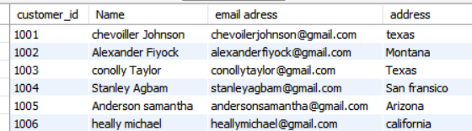
Figure 1 showing the customer entity.
The customer table above shows the first six rows in the customer table which conatins the primary key labelled as custome_id, along with the customer name and address. Elmasri, R., & Navathe, S. B. (2016). Fundamentals of database systems (7th ed.). Pearson. They are also used to establish relationship between two or more entities(tables). One of the key properties a primary key must have is the uniqueness of identity i.e, each table must have only one primary key although in some senerios, it canbe composed of multiple column ( a composite primary key).as shown in the order details table .

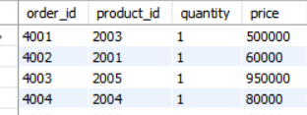
Figure 2 showing the order details table explaining the cincept of a composite entity
Foreign key: This is the attribute(column) of data in one table that refers to the unique data values often in the primary key of another table (Coronel, C., & Morris, S. (2017). Database systems: Design, implementation, and management (12th ed.). Cengage Learning.). To ensure the links between a foreign key and primary keys aren't broken, foreign key constraints are created to prevent actions that would damage the links between the two tables and prevent erroneous data from being added to the foreign key column.

Aims and objectives
The aim of this introduction is to provide a clear, accessible foundation in data analysis, equipping learners with the skills to explore and interpret data effectively. The objectives are:
- Learn the concepts of database and database management systems along with the concepts and approaches of database design, administration and management.
- Learn the principals and science behind querying the data from a database management system to use for business analytics and implement the queries to retrieve the data from MySQL.
- Write advanced SQL queries to manipulate, wrangle and derive insights from large database systems.
LITERATURE REVIEW

An E-commerce database organizes patrons’ personal attributes, products in stock, purchases, payments, shipping, warehouse and inventory, and client reviews. It facilitates uninterrupted trading by maintaining quick access to data, safe storage, and uniformity across all system modules. This plays a role in E-commerce which is a global phenomenon and is ideal with considerable data to make decisions, customize data for clients, and meet client expectations. This databse will be used to answer the research objectives, starting with the first. Coronel, C. and Morris, S. (2017) Database systems: design, implementation, and management. 12th edn. Boston, MA: Cengage Learning.
The data model for the database is then designed and drafted via an entity relationship diagram, which then build the conceptual framework that shows the primary entities in the system, including customer, product, order, payment, shipment and warehouse, and the relationships that connect them. For example, a customer can place multiple orders, an order can contain several products, and a product can relate to the inventory and shipment entities. These relationships, illustrated visually, help the ERD guide the transition from business requirements to a formal database schema. Additionally, it maintains the system in a normalized state to eliminate redundancy while allowing queries that pass business processes in the real world, such as order tracking, payment and inventory control.

MATERIALS AND METHODS
This section contains the procedure and method to solving each of the objectives as well as the steps involved, starting from the first objective which is about learning and understanding the concept of database management system

Objective 1: Learning the database concept and the approaches to database design
The E-commerce data model introduced above was used in understanding the concept of database. The data model of this relational model contained 10 different entities( data models) the customer entity, this table helps in collecting the customer details such as their name, address and phone number, it is shown in figure 1 above. The product details which shows the available products and their product details. It entails the product id as the unique identifier(primary key), the product description(product name), amount, the available quantity, as well as the product category and the customer id(foreign key). This product information is to be updated every month as new products might be available and also, the quatity of product available changes with time. It also contains the add to cart, the order and the order details, the payment information, then lastly the warehouse, the shippment, the customer/consumer ratings.
The conceptual model of the E-commerce database was designed in such a way that each customer is allowed to make an enquiry on more than one product, hence establishing a one- to-many relationship between the customer and product entity, it was also designed in a such a way that one product can e added to cart multiple times, establishing a one to many non-identifying relationship between the product and cart as well, it was also modelled in such a way that many products can have many orders from different customers hence, establishing a many to many relationship between the product and order entity with the order details as the intermediate entity(bridge table) which can be found in figure 2. Moreover, only one order can be added to cart hence, establishing a one-to-one relationship between the add to cart and the orders placed. In addition, after the customers have placed their orders, then they make the payment based on the products ordered. Hence, establishing a one-to-one relationship between order and payment. In addition, the data model also established a one to many relationship between the warehouse and the shippment entities. The warehouse contains the informations so the different branches of the company as well as their location and their capaity and the shippment entity however, the shippment entity(table) gives information about the shippment details for each products ordereed. The data model also established a one-to-many relationship between the product table and the inventory table. In addition, the model also establish a one to many relationship between the order details bridge table which contains the product and the order id as well as the product id, allowing us to map out shippment details of every of the products ordered. Lastly, after the customers have gotten their products via shipping, they are requierd to leave a review hence, establishing a one-to -one relationship between customer and the customer review(rating). this data model. This conceptual model aligns with the Amazon e-commerce data model, which incorporates entities such as Customer, Product, Order, Payment, Shipment, and Review. These entities are connected through one-to-many, many-to-many, and one-to-one relationships, with bridge tables such as OrderDetails used to resolve many-to-many cases.

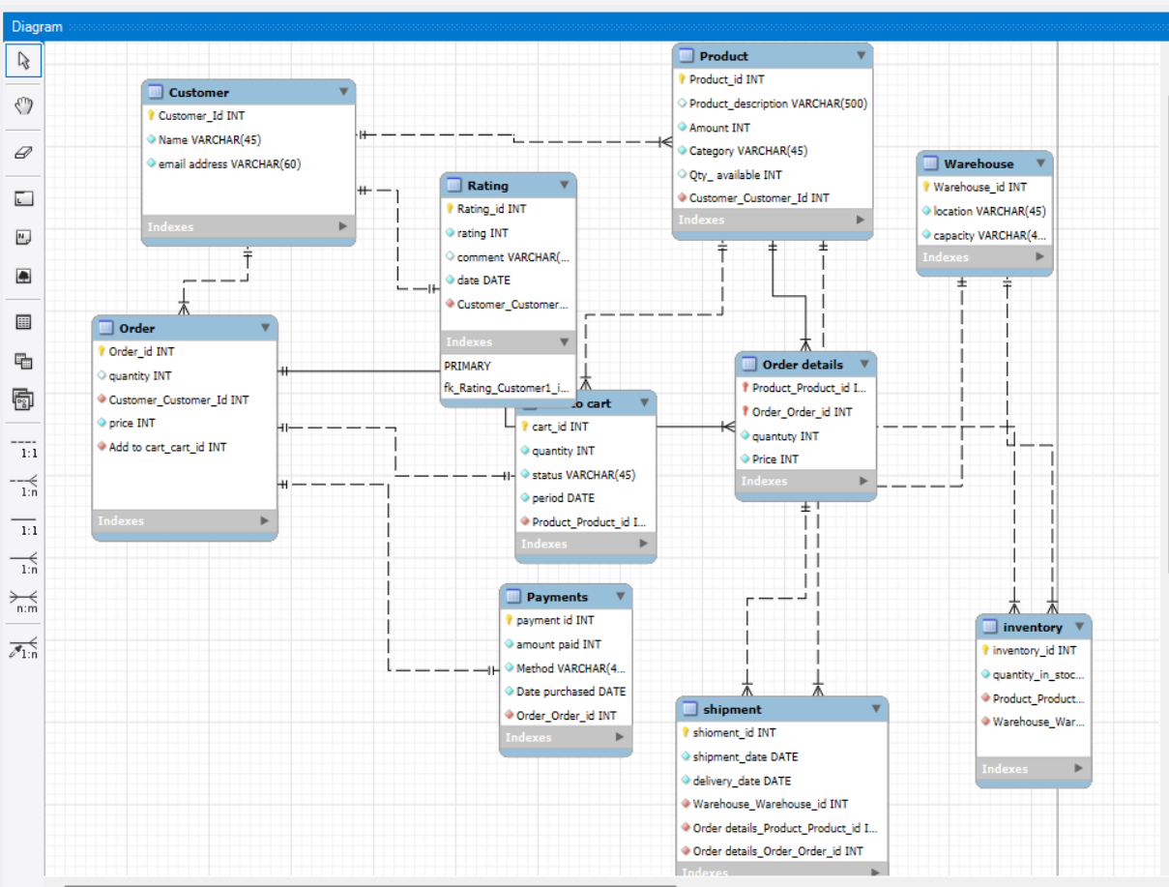
Figure 3; The entity relationship diagram showing the conceptual model of the relational database model.
Consistency, Availability and Partition tolerance
The notion of consistency means when the database is most up-to-date and accurate. Moreover, it means database updates are made according to the rules set in the beginning with respect to constraints, cascades, triggers, and all other elements. Furthermore, consistency guarantees an arrangement whereby any modifications made in one version of the database are distributed to all other versions, maintained with correctness and precision, irrespective of the geographical location of transaction in the database.
There are various types of consistency; which are te strong and week consistency. The strong ensures that all users, regardless of where they access the database, see the same, correct, and accurate data at the same time. The weak consistemcy on the other hand, allows temporary differences across database replicas. Updates to data may not appear immediately to all users, but the system guarantees that the data will eventually become consistent.

Availability means the infrastructure, systems, processes, and policies an enterprise puts in place to keep its data accessible and usable to those who are permitted to do so. Although organizations might face an increase in complexity and volume, the essence of data availability is having data at hand without needless delay to users, applications, or systems. As the basis of business operations and intelligent decision making, companies need to capture the core principles of data availability to form the basis of its operations. To put it another way, data availability is the practice of ensuring that an organization’s data is accessible and usable at the time of need. This involves a delicate alignment of the conflicting components of data accuracy, data integrity, and data security in a manner that allows its efficient extraction and use by authorized users.

Consequently, data availability would include the boundaries created by validation, and constraints of other components like efficient systems for data storage, real time data retrieval, retrieval systems, data networks, responsive systems and other supporting structures like overall system and network performance. Anticipated and unanticipated disasters, systems malfunctions, and unscheduled hardware failures are controlled with systems to provide data backup and duplication to guarantee data availability.

Partition tolerance on the other hand, allows a distributed system to continue operating despite arbitrary partitioning due to network failures. When a network partition occurs, some nodes become isolated and cannot communicate with others. A partition-tolerant system ensures that these isolated nodes can still process requests and maintain functionality. This capability is crucial for distributed systems deployed across multiple geographic locations, where network partitions are more likely to occur. Partition tolerance prevents the system from becoming entirely unavailable during network issues, ensuring continuous operation and reliability. However, maintaining partition tolerance often requires trade-offs with consistency and availability, as the system must balance these factors to handle network disruptions effectively.

A distributed database system cannot guarantee all three properties of consistency, availability, and partition tolerance. This is so because of the inherent contradictions the system can encounter when there is a network issue. The problem primarily starts with a network breakdown. This is when the system is forced to make a decision about which of the three properties must be reduced. A system may be available and responsive to queries and close a network partition. This, however, may lead to a violation of consistency, especially when responses are based on stale data. The opposite may be true when a system blocks or delays some responses to queries to ensure consistency. This may, however, significantly cut down availability, and the system may no longer be responsive to queries. Partitions in a distributed system are unavoidable, and so a database cannot guarantee all three properties simultaneously. Looking at the properties of a distributed database, a system can only aim to maximize two of the three at the expense of the other.In most real-world distributed systems, the two properties that are usually prioritized are availability and partition tolerance.

Objective 2: Principals and science behind querying the data and data management
The second objective is aimed at grasping the fundamentals and the science on how to query and handle data effectively. The process of querying entails extracting valuable insights from a data repository through the use of SQL and other query languages. The conversion of information is guided by the principles of relational algebra and set theory in tandem with logic to ensure precision and concordance in data retrieval. Data management entails organizing and controlling access and securing data through its lifecycles. This entails the application of normalization theory to eliminate superfluous data, the enforcement of integrity constraints through primary and foreign keys, and the sustaining of system performance and scalability with indices and optimization. The combination of querying and data management principles outlined above form the fundamental mechanics of database systems enabling the conversion of raw data to useful information.

The e-commerce database was used to answer this objective, starting with the product category with the highest product. The figure 4 and 5 below shows the query and the output respectively

Figure 4: The SQL query behind the product category with the higest cost price

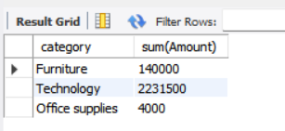
Figure 5; The Result, showing the cost price per product category in a table.
From the table above, we can conclude that the technology category has more expensive product as compared to the other two product categories.
Then, we proceed to observing the quantity of products available per product category
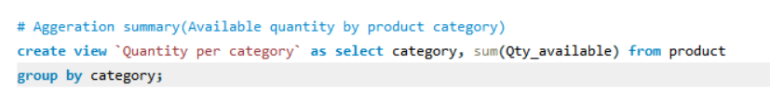
Figure 6: The SQL query behind the product category with the highest availability in stock.

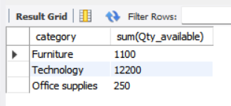
Figure 7: The output
The above result shows that the technology category has the highest availability in stock followed by the furniture category while the office supplies occupies the least availability.
Reason behind the findings: Dealing with an E-commerce store, one of the major entities to keep track of are the product and the customer entities which are the people, and the services that attracts the people to the company, which is the product category.

Advanced SQL queries for analytics :
This section discusses the key SQL techniques used for advanced business queries. JOIN operations with is based on combining data across multiple tables, while GROUP BY with HAVING supports aggregation and filtering of summarized results. CASE statements allow conditional logic within queries, and subqueries(both correlated and non-correlated) enable nested data retrieval. Finally,window functions are applied for tasks like ranking, running totals, and trend analysis. Together, these methods provide powerful tools for extracting insights and supporting decision-making. Making reference on the E-commerce data model as well, we will start by creating an inner join the available customers and products this way, we will be able to know the customers that are currently active in the company as well as the products endorsed by them as well as the order placed.

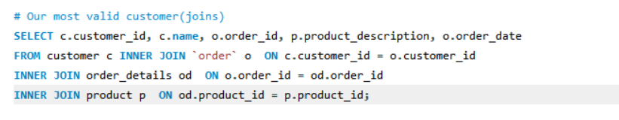
Figure 8: The SQL quey behind the inner join between the customers, products and order placed

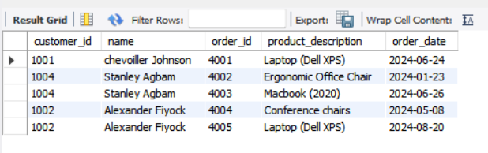
Figure 9: The SQL table output
The output above shows that only three out of our potential eight customers are currently purchasing the company’s product. With Alexander and Stanley purchasing two different product while chevoiller only purchased a product once.

Aggregation( Group BY and HAVING)
This section allows to dig further into the data set(imported data), allowing us to view the customers who spent ₦500,000 or more on the company. The entities involves the customer entity, order and the payment entity.
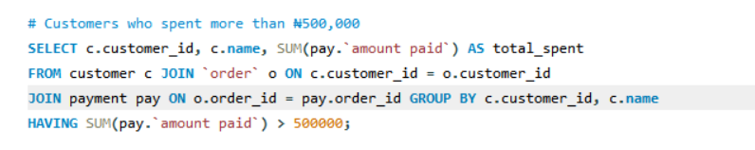
Figure 10: The SQL query behind exploring the customers who spent more who spent ₦500,000 or more on the company.

This query sums up all amounts paid by each customer, grouping the results by customer ID and name. The HAVING clause ensures that only customers whose cumulative payments exceed ₦500,000 are included in the output.

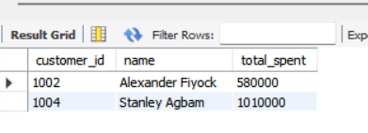
Figure 11: The SQL table output
The Table shows that only two out of our three customers have purchased items worth more than ₦500,000.

Conditional Logic(usin CASE)
This section standardizes cart statuses in the Add to Cart table using a CASE expression. It converts Ordered to Completed, Active to Pending, Abandoned to Cancelled, and flags any other values as Unknown. This ensures consistency and easier interpretation in reporting.

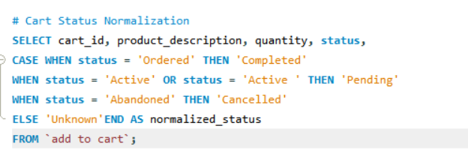
Figure 11: SQL query behind the Normalization



Figure 12: The SQL Table output
This table shows that out of 5 out of eigt orders have been completed , two cancelled while the remaining one is still active.
Subqueries(Correlated or non-correlated)
This section subqueries to identify customers who spent more than the average across all customers. The nested queries calculates each customer’s total spending as well as the overall average spending, and the main query returns only those above the average money spent between the customers. This highlights premium customers in comparison to the wider customer base.

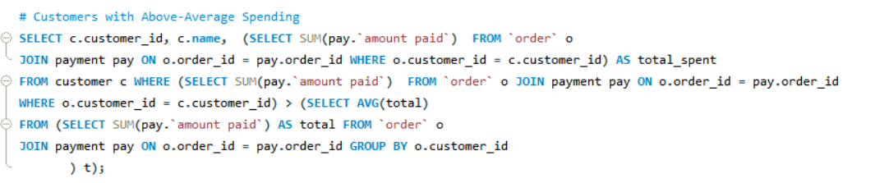
Figure 13: The subquery
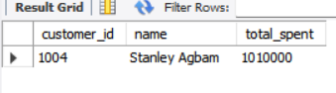
The table abive shows that Stanley Agbam is our most active customer, being the only customer to spend above average.

Use of window functions for rankings or trends
In this section, we made use of the windows function to analyse the monthly sales trend in the E-commerce database. By analysing the trend, we have a visual on the product sales made on each product.

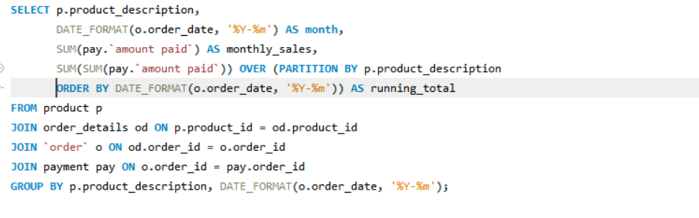
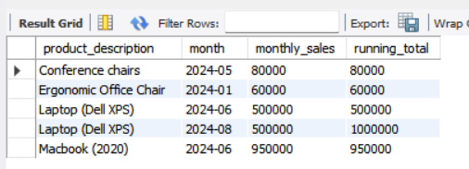
Figure 14: showing the SQL query and the sales trend per product
The table above shows that the higest sales were made in the month of june and august with deals of ₦500,000 and ₦1000000 respectively.

Objective 3: Query performance and optimization
While working on the E-commerce database, I understood the complexities of SQL queries, especially ones with multiple joins and aggregations, and their performance on large datasets. A case in hand is the calculation of monthly sales trends per product. The query accesses the product, order_details, order, and payment tables and joins them multiple times. The answer is correct, but the performance is poor because of the multiple joins and grouping. As suggested by the course assinment, we will be applying indexes and some common table expression to mae the queries faster and the easy retrival of informations or data.

Applying Indexes:
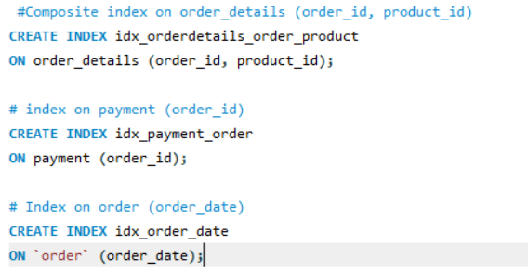
Figure 15: Adding index on the product, order and the order details entities

This thereby ensures faster and easier retrieval of information , hence, reduces the need for a full table scan when the order details entity with the product and order entity. Also, speeding up the retrieval of payment records that correspond to specific orders. Since the relationship between orders and payments is frequently queried, this index allows the database to immediately find the matching payment details without scanning the entire table.

Re writing complex queries or sub queries
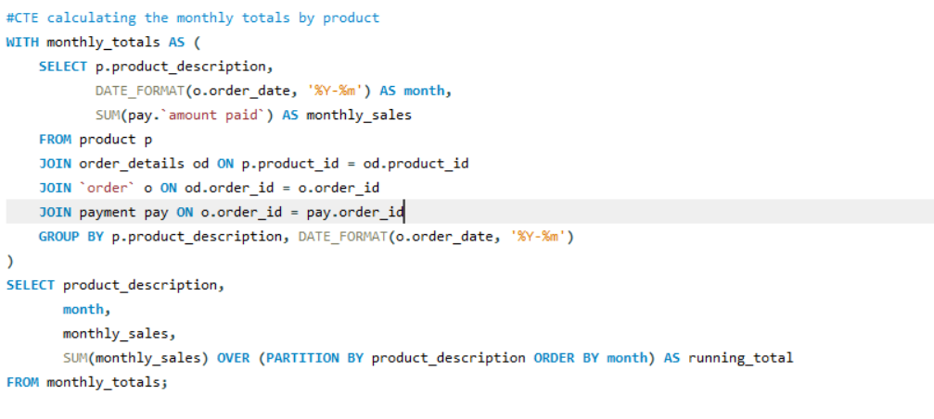

Figure 16: SQl query behind the Optimization of Monthly Sales Calculation Using Common Table Expressions (CTEs)\

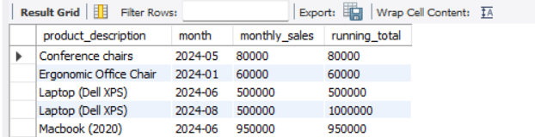
Figure 17: The sales trend output:
The SQl table above shows that the highest sales were made in august with a total sales of one milion naira. The least sales was made on the first month which might be due to the fact that the customers might just be drafting their scale of preference at the moment, hence leading to low sales, with a total sale of sixty thousand naira.
Alternatively, we can choose to Improve the speed of trend analysis. Rather than recalculating the monthly sales from several joined tables every time, the results can be kept in summarized tables, in this instance productmonthlysales. This table holds aggregated values of each product’s sales on a monthly basis. Consequently, the queries become simpler. This is because the system is only reading from the summary table, avoiding the need to do complex joins and aggregations every time across product, order_details, order, and payment.

CHAPTER TWO

This section discusses on the conclusion, recommendation and the references used in the study.

CONCLUDING REMARKS

In conclusion, this report highlighted the fundamentals of database design and data analytics, using an e-commerce model to illustrate concepts such as entities, relationships, and normalization. Through SQL queries and optimization techniques, it showed how raw data can be transformed into valuable insights for decision-making. Overall, the study emphasizes the role of relational databases and analytics as vital tools for improving efficiency and supporting business intelligence in today’s data-driven world. Based on the database models, these are the few things I recommend.
Invest in database security – Strong security protocols should be enforced to protect sensitive data, especially in e-commerce platforms handling customer information and payments.
Encourage continuous training – Students and professionals in data analytics should undergo regular training on advanced SQL, data modeling, and modern database tools to keep up with industry practices.

BIBLIOGRAPHY

Coronel, C. & Morris, S. (2017) Database systems: Design, implementation, and management. 12th edn. Boston, MA: Cengage Learning.
Davidson, L. & Moss, P. (2012) Pro SQL Server 2012 relational database design and implementation. New York: Apress, pp. 139–172.
Elmasri, R. & Navathe, S.B. (2016) Fundamentals of database systems. 7th edn. Boston, MA: Pearson.
Teorey, T.J., Lightstone, S. & Nadeau, T. (2011) Database modelling and design. 4th edn. Burlington, MA: Morgan Kaufmann
Vertabelo Database Modeler (2020) ER diagram for online shop (E-commerce database model explained).

